Assignment 24.1

# Assignment-24.1

Explain with an example in brief.

● Hive Data Definitions

● Hive Data Manipulations

● HiveQL Manipulations

Ans: Hive supports Data definition Language(DDL), Data Manipulation Language(DML) and User defined functions.

Hive DDL Commands

create database

drop database

create table

drop table

alter table

create index

create views

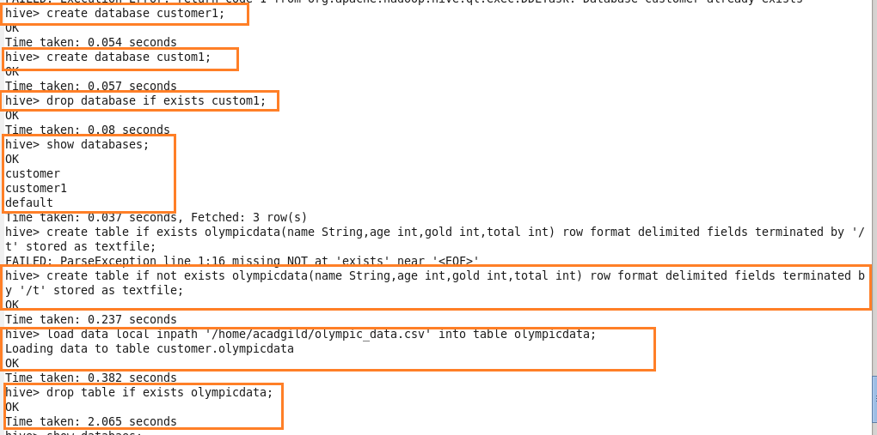

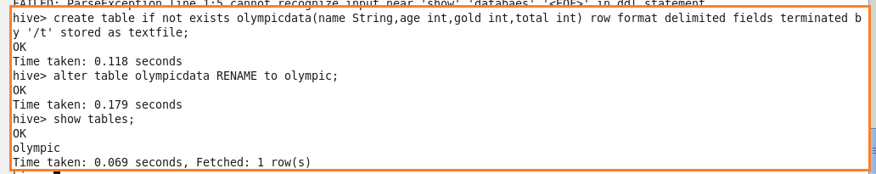

Hive DML Commands and hiveql manipulations are:

Select

Where

Group By

Order By

Load Data



